**Selenium Test Report**

**On**

**http://cup.edu.in/**



**School of computer application**

Software Engineering Practices (CAP 437)

**Session 2022-2024**

**Submitted to: Submitted by:**

Name: Dr. Shuja Rashid Mirza Name: Satyam Mishra

(Dept of. Computer Science) Reg. no: 12212256

Course: MCA

**Department of computer Science**

**Lovely Professional University Jalandhar Punjab (144401)**

**India.**

**Test Case 1**

|  |  |  |  |  |  |  |  |  |  |
| --- | --- | --- | --- | --- | --- | --- | --- | --- | --- |
| **Test Case ID** | **Name** | **Description** | **Test Steps** | | | **Test Case Status** | **Test Status**  **(P/F)** | **Test Priority** | **Defect Severity** |
| **Step** | **Expected** | **Actual** |
| About | Testing Web page of About page in sublinks | To Verify the link is working using sublinks | Open website | Website Open | Website Open | Completed Successfully | Pass | High | Low |
| Click on CUP profile | CUP Profile Window open | CUP Profile Window open | Pass | High | Low |
| Click on Vision misson logo | Vison Misson logo Window open | Vison Misson logo Window open | Pass | High | Low |
| Close Website | Close Website | Website Closed | Pass | High | Low |

**Screenshot of test case ID: About**

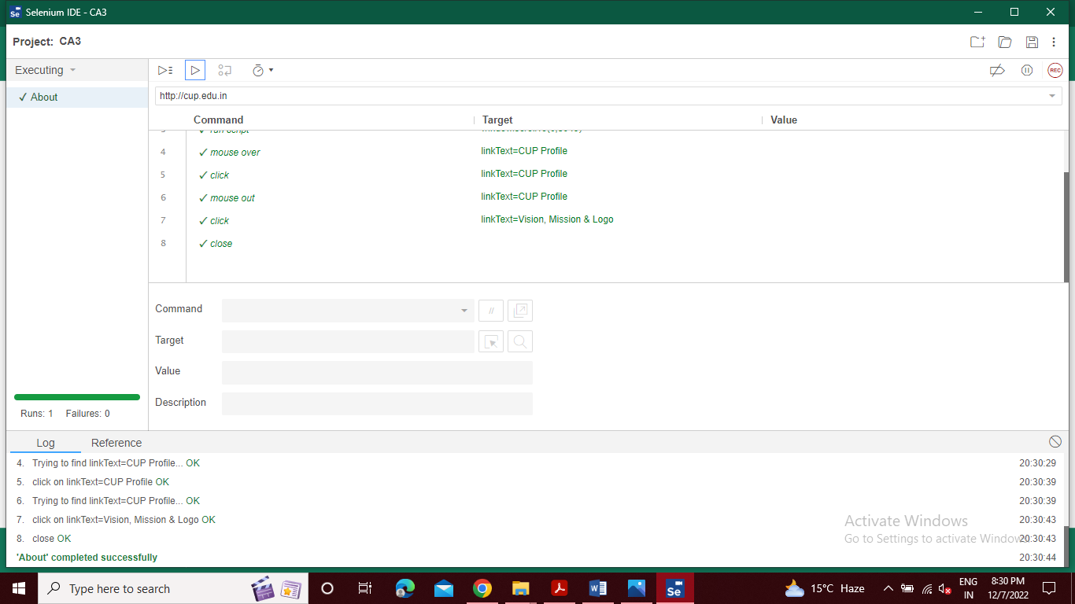

**Java Code Generated by Selenium**

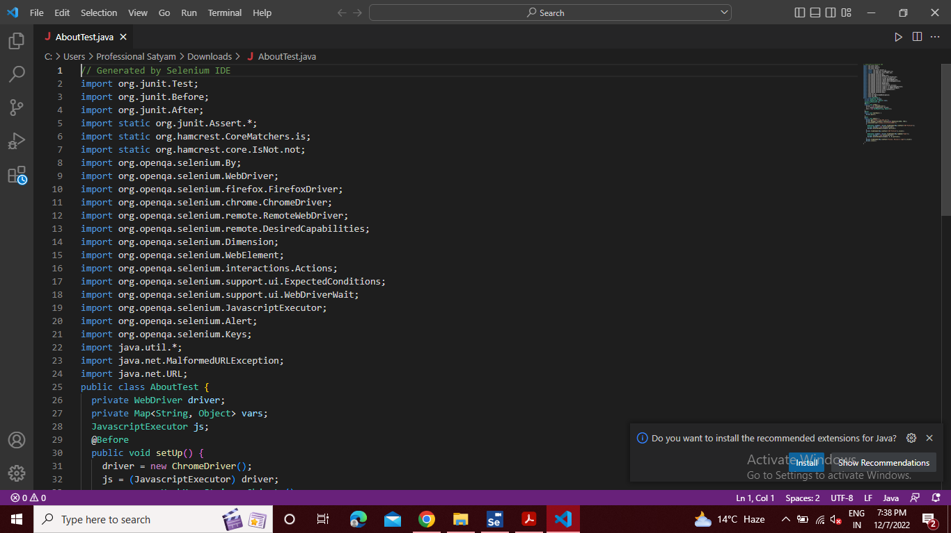

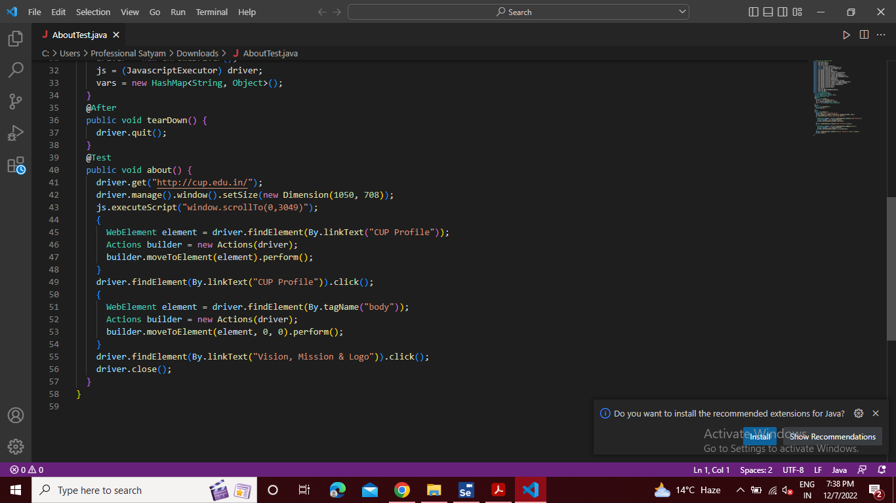

**Test Case 2**

|  |  |  |  |  |  |  |  |  |  |
| --- | --- | --- | --- | --- | --- | --- | --- | --- | --- |
| **Test Case ID** | **Name** | **Description** | **Test Steps** | | | **Test Case Status** | **Test Status**  **(P/F)** | **Test Priority** | **Defect Severity** |
| **Step** | **Expected** | **Actual** |
| Administration | Testing Web page of About page in sublinks | To Verify the link is working using sublinks | Open website | Website Open | Website Open | Completed Successfully | Pass | High | Low |
| Click on Vistors | Visitors Window open | Visitors Window open | Pass | High | Low |
| Click on Vice Chancellor | Vice Chancellor Window open | Vice Chancellor Window open | Pass | High | Low |
| Close Website | Close Website | Close Website | Pass | High | Low |

**Screenshot of test case ID: Administration**

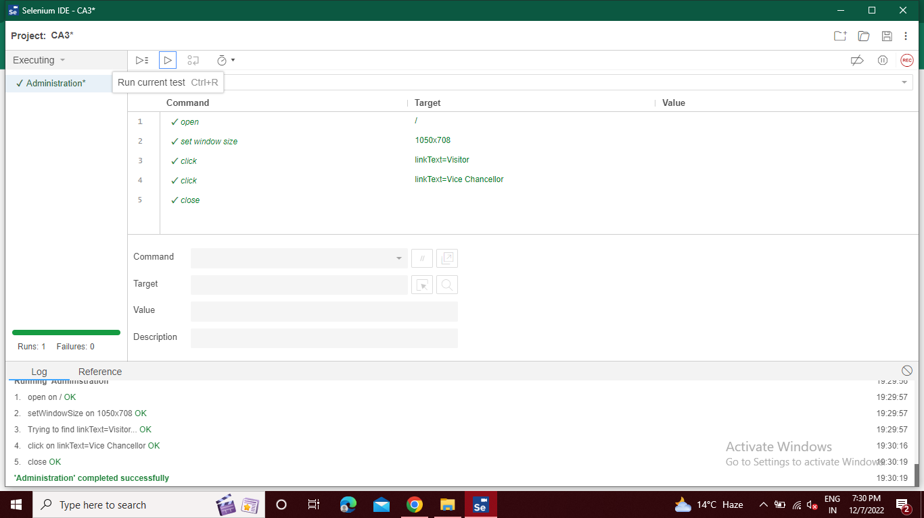

**Java Code Generated by Selenium**

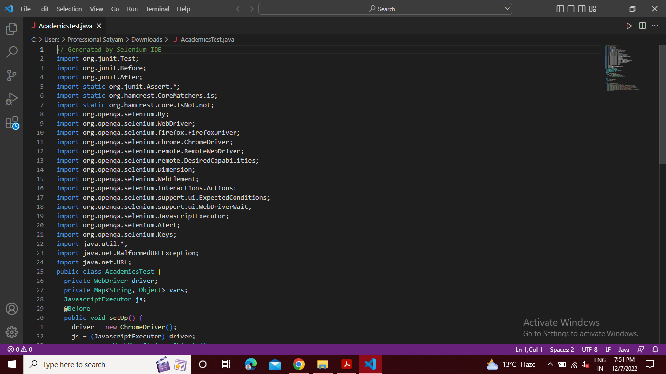

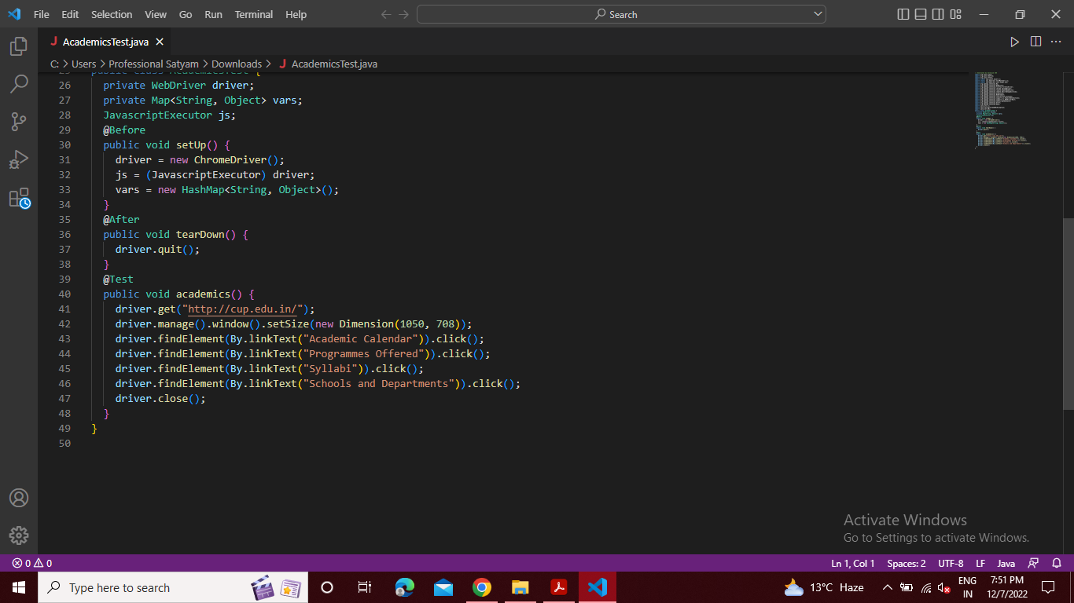

**Test Case 3**

|  |  |  |  |  |  |  |  |  |  |
| --- | --- | --- | --- | --- | --- | --- | --- | --- | --- |
| **Test Case ID** | **Name** | **Description** | **Test Steps** | | | **Test Case Status** | **Test Status**  **(P/F)** | **Test Priority** | **Defect Severity** |
| **Step** | **Expected** | **Actual** |
| Academics | Testing Web page of About page in sublinks | To Verify the link is working using sublinks | Open website | Website Open | Website Open | Completed Successfully | Pass | High | Low |
| Click on Academic Calendar | Academic Calendar Window open | Academic Calendar Window open | Pass | High | Low |
| Click on Programs Offered | Programs Offered Window open | Programs Offered Window open | Pass | High | Low |
| Click on Syllabus | Syllabus Window open | Syllabus Window open | Pass | High | Low |
| Click on Schools and Departments | Schools and Departments Window open | Schools and Departments Window open | Pass | High | Low |
| Close Website | Close Website | Close Website | Pass | High | Low |

**Screenshot of test case ID: Academics**

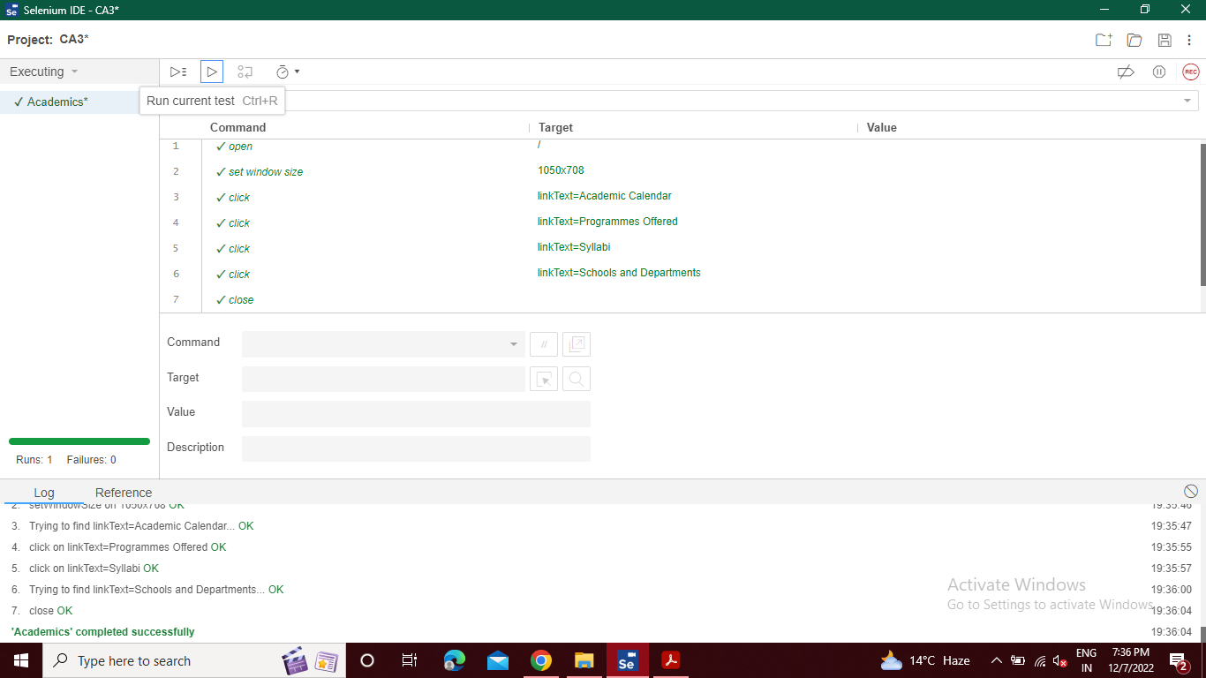

**Java Code Generated by Selenium**

